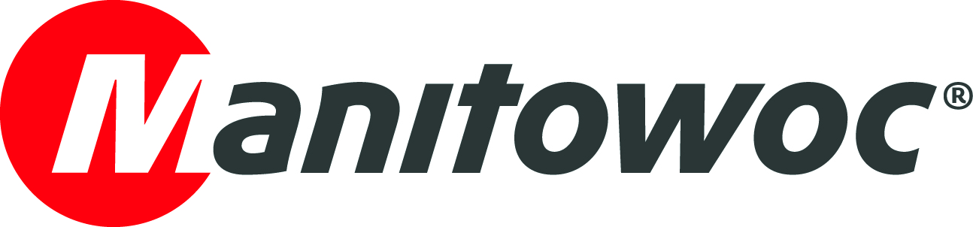
CAPTION RELEASE

June 19, 2019

Manitowoc sells and ships 1,000th Igo T 85

Manitowoc’s manufacturing facility in Charlieu, France has shipped its 1,000th Igo T 85. The landmark self-erecting crane has been sold to a customer in Benelux.

The Igo T 85 was launched in 2008 and immediately rose in popularity across Europe, particularly in Germany and France. Since then, it has become well known in Asia and the USA. In 2011, an upgraded model – the Igo T 85 A – was developed to include a third additional mast section and new slewing system, reaching 38 m height under hook.

With its 45 m jib radius, 38 m height under hook and maximum capacity of 6 t, the Igo T 85 A provides the easy logistics of a self-erecting crane and the high capacities of small hammerhead top-slewing cranes, making it ideal for residential construction jobsites.

The Charlieu facility is one of the major French Potain manufacturing plants and produces self-erecting cranes, as well as mechanisms for all cranes. It was established in 1955 by company founder Faustin Potain and is where the innovation for self-erecting cranes began.

-END-

CONTACT
Cristelle Lacourt
Manitowoc
T +33 472 182 018
cristelle.lacourt@manitowoc.com

ABOUT THE MANITOWOC COMPANY, INC.
The Manitowoc Company, Inc. (“Manitowoc”) was founded in 1902 and has over a 116-year tradition of providing high-quality, customer-focused products and support services to its markets and its 2018 net sales were approximately $1.8 billion. Manitowoc is one of the world's leading providers of engineered lifting solutions. Manitowoc, through its wholly-owned subsidiaries, designs, manufactures, markets, and supports comprehensive product lines of mobile telescopic cranes, tower cranes, lattice-boom crawler cranes, and boom trucks under the Grove, Manitowoc, National Crane, Potain, Shuttlelift and Manitowoc Crane Care brand names.

THE MANITOWOC COMPANY, INC.
One Park Plaza – 11270 West Park Place – Suite 1000 – Milwaukee, WI 53224, USA
T +1 920 684 4410
www.manitowoc.com

